**Database for Zen Class Programme**

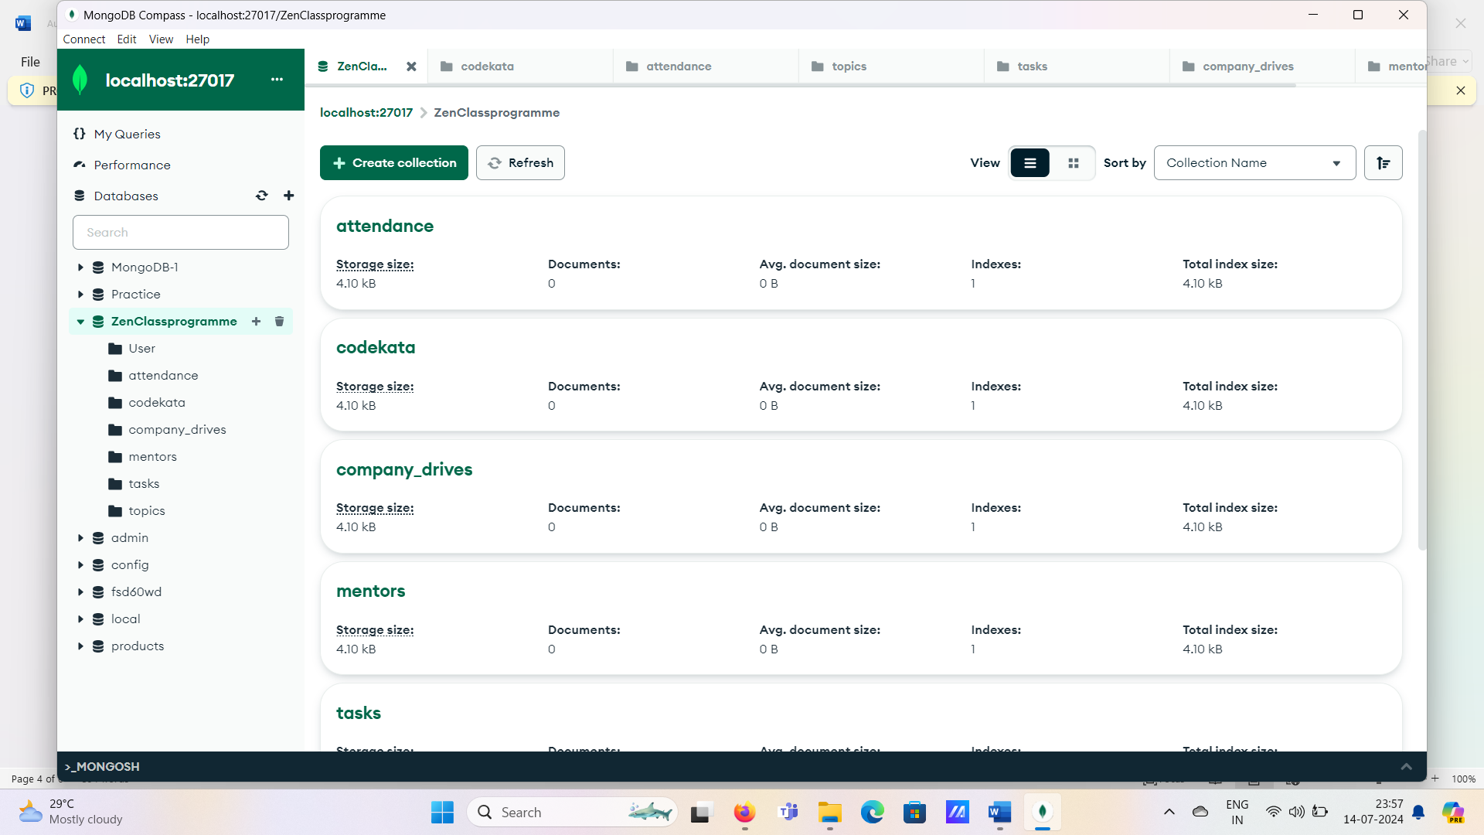

**Q1. Find all the topics and tasks which are thought in the month of October?**  
db.topics.aggregate([

{

$lookup: {

from: "tasks",

localField: "topic_id",

foreignField: "topic_id",

as: "task_info"

}},

{$match: {

$and: [

{ topic_date: { $gte: new Date("01 oct-2020"), $lt: new Date("01-nov-2020") } },

{

$or: [

{ "task_info.due_date": { $gte: new Date("01 oct-2020"), $lt: new Date("01-nov-2020") } },

{ "task_info.due_date": { $exists: false } }

]

}]

}},

{

$project: {

_id: 0,

topic_id: 1,

topic: 1,

topic_date: 1,

tasks: "$task_info.task",

due_dates: "$task_info.due_date"

}}

])

**2)** **Find all the company drives** **which appeared between 15 oct-2020 and 31-oct-2020?**  
  
db.companydrives.find({

$or: [

{ drive_date: { $gte: new Date("15 oct-2020") } },

{ drive_date: { $lte: new Date("31-oct-2020") } }

]

})  
  
  
**3) Find all the company drives and students who are appeared for the placement?**  
  
db.company_drives.aggregate([

{

$lookup: {

from: "users",

localField: "user_id",

foreignField: "user_id",

as: "user_info"

}},

{

$project: {

_id: 0,

company: 1,

drive_date: 1,

students: "$user_info"

}}

])

**4) Find the number of problems solved by the user in codekata?**  
  
db.codekata.aggregate([

{

$lookup: {

from: "users",

localField: "user_id",

foreignField: "user_id",

as: "user_info"

}},

{

$group: {

_id: {

user_id: "$user_id",

user_name: "$user_info.name"

},

total_problems_solved: { $sum: "$problems" }

}},

{

$project: {

_id: 0,

user_id: "$_id.user_id",

user_name: "$_id.user_name",

total_problems_solved: 1

}}

])

**5) Find all the mentors with who has the mentee's count more than 15?**

db.users.aggregate([

{

$match: { mentor_id: { $exists: true } }

},

{

$group: {

_id: "$mentor_id",

mentor_name: { $first: "$mentor_name" },

mentee_count: { $sum: 1 }

}},

{

$match: { mentee_count: { $gt: 15 } }

},

{

$project: {

_id: 0,

mentor_id: "$_id",

mentor_name: 1,

mentee_count: 1

}}

])

**6) Find the number of users who are absent and task is not submitted  between 15 oct-2020 and 31-oct-2020?**  
  
db.attendance.aggregate([

{

$lookup: {

from: "topics",

localField: "topic_id",

foreignField: "topic_id",

as: "topics"

}},

{

$lookup: {

from: "tasks",

localField: "topic_id",

foreignField: "topic_id",

as: "tasks"

}},

{

$match: {

attended: false,

"tasks_submitted": false,

$and: [

{ "topics.topic_date": { $gte: newDate("15-oct-2020") } },

{ "topics.topic_date": { $lte: newDate("31-oct-2020") } },

{ "tasks.due_date": { $gte: newDate("15-oct-2020") } },

{ "tasks.due_date": { $lte: newDate("31-oct-2020") } }

]

}},

{$count: "No_of_students_absent"}])